1. **Height Vs Earn by using geom_point()**

## Load the ggplot2 package

library(ggplot2)

theme_set(theme_minimal())

## Set the working directory to the root of your DSC 520 directory

setwd("C:/Users/ragun/Documents/GitHub/dsc520-master/DSC520-new")

## Load the `data/r4ds/heights.csv` to

heights_df <- read.csv("data/r4ds/heights.csv")

ggplot(heights_df, aes(x=height, y=earn)) + geom_point()

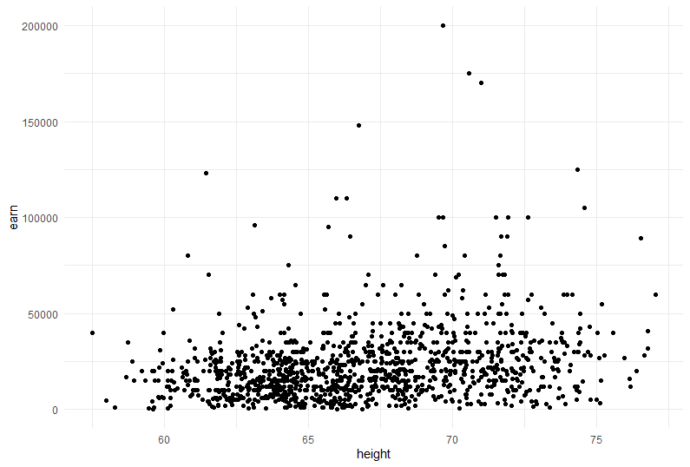

1. **Age Vs Earn by using geom_point()**

## `age` vs. `earn`

ggplot(heights_df, aes(x=age, y=earn)) + geom_point()

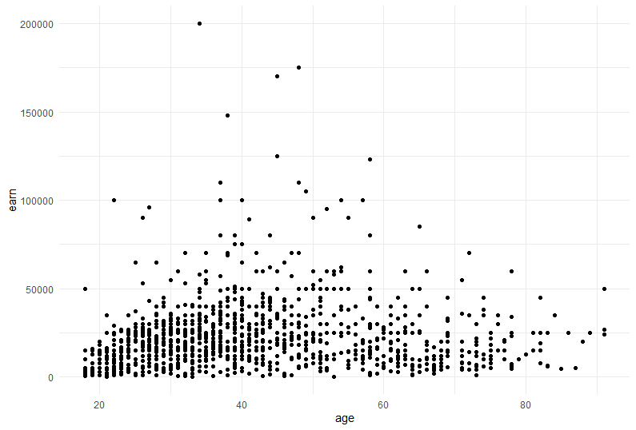

1. **Ed vs Earn by using geom_point()**

## `ed` vs. `earn`

ggplot(heights_df, aes(x=ed, y=earn)) + geom_point()

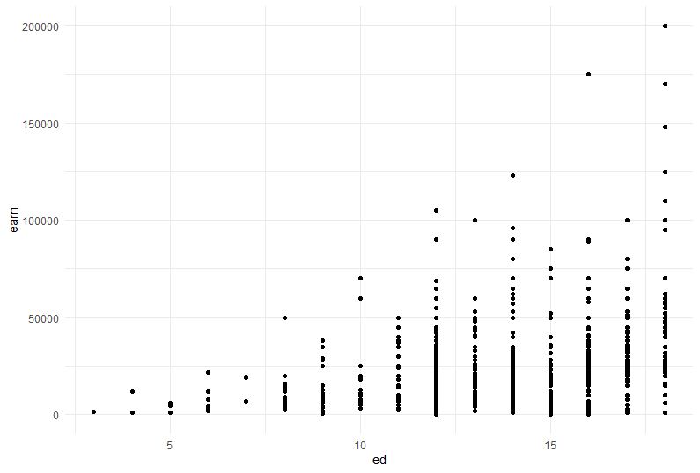

1. **Height vs Earn by using geom_point() and geom_smooth()**

## `height` vs. `earn`

ggplot(heights_df, aes(x=height, y=earn)) + geom_point() + geom_smooth()

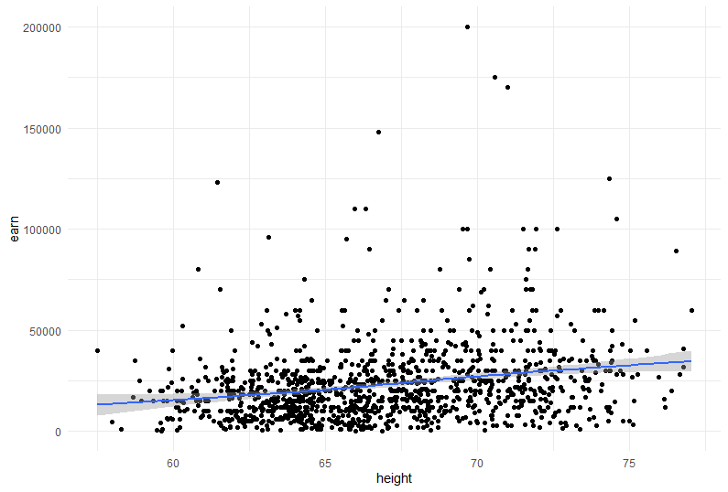

1. **Age Vs Earn by using geom_point() and geom_smooth()**

## `age` vs. `earn`

ggplot(heights_df, aes(x=age, y=earn)) + geom_point()+ geom_smooth()

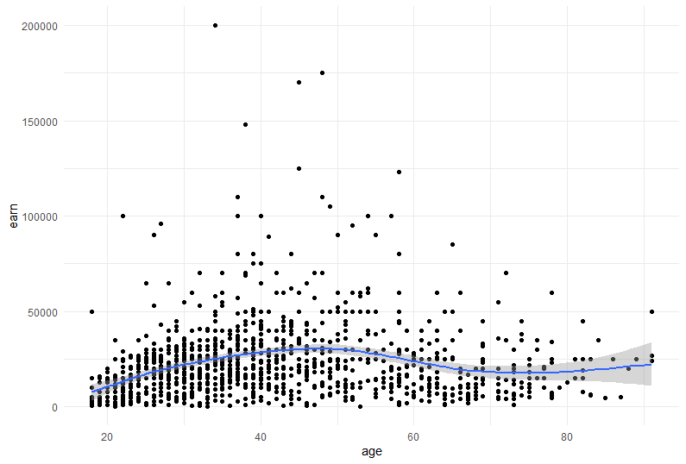

1. **Age Vs Ed by using geom_point() and geom_smooth()**

## `ed` vs. `earn`

ggplot(heights_df, aes(x=ed, y=earn)) + geom_point()+ geom_smooth()

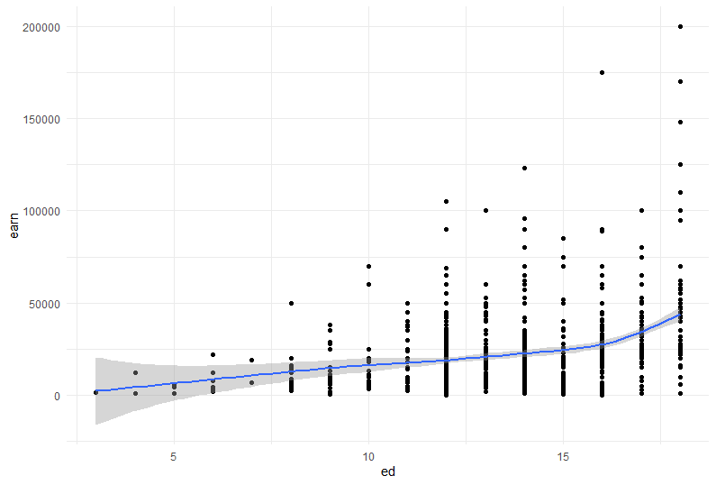

1. **Height vs Earn by geom_point and including color**

## Create a scatterplot of `height`` vs. `earn`. Use `sex` as the `col` (color) attribute

ggplot(heights_df, aes(x=height, y=earn, col=sex)) + geom_point()

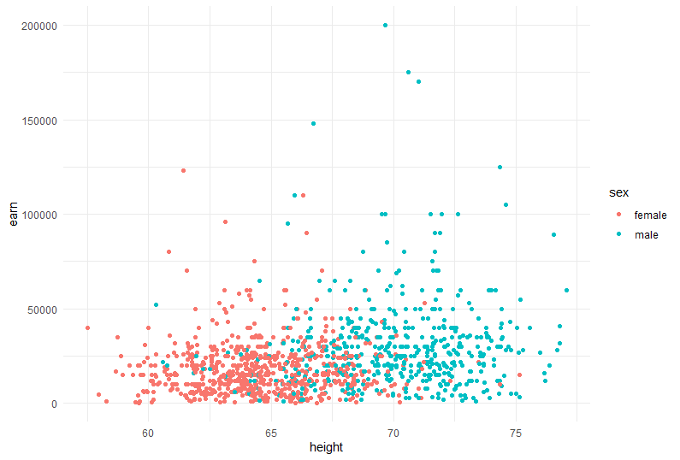

1. **Heigth vs Earnings by Using `ggtitle()`, `xlab()`, and `ylab()` to add a title, x label, and y label**

## Using `ggtitle()`, `xlab()`, and `ylab()` to add a title, x label, and y label to the previous plot

## Title: Height vs. Earnings

## X label: Height (Inches)

## Y Label: Earnings (Dollars)

ggplot(heights_df, aes(x=height, y=earn, col=sex)) + geom_point() + ggtitle("Height vs. Earnings") + xlab("Height (Inches)") + ylab("Earnings (Dollars)")

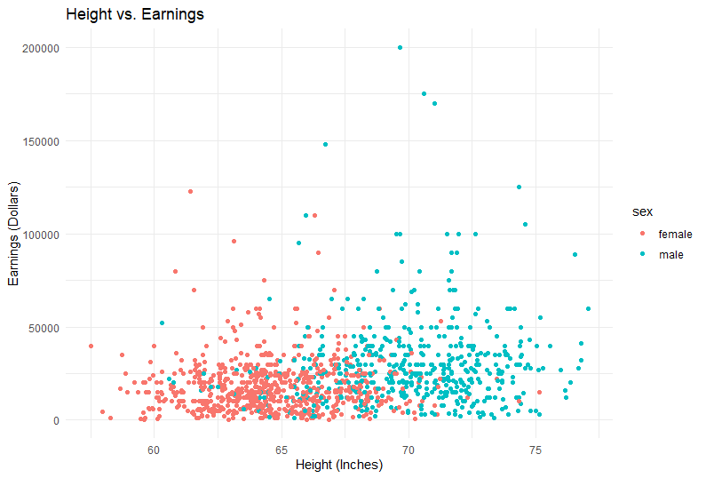

1. **Histogram of the earn Variable**

## Create a histogram of the `earn` variable using `geom_histogram()`

ggplot(heights_df, aes(earn)) + geom_histogram()

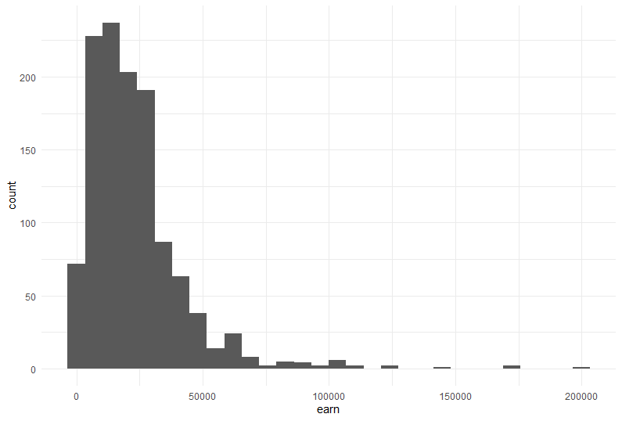

1. **Histogram of the `earn` variable using `geom_histogram() and bin as 10**

## Create a histogram of the `earn` variable using `geom_histogram()`

## Use 10 bins

ggplot(heights_df, aes(earn)) + geom_histogram(bins = 10)

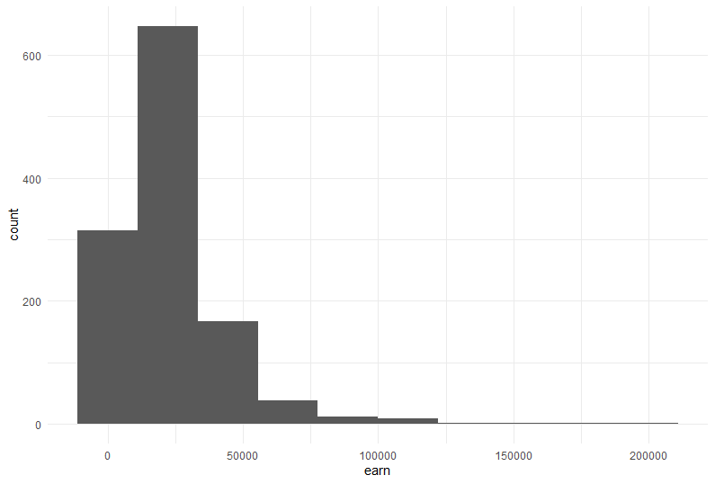

1. **Kernel density plot of `earn` using `geom_density()`**

## Create a kernel density plot of `earn` using `geom_density()`

ggplot(heights_df, aes(earn)) + geom_density()

